AIM OF THE EXPERIMENT:
To determine the settlements due to primary consolidation of soil by conducting one dimensional test to determine:
- Rate of consolidation under normal load.
- Degree of consolidation at any time.
- Pressure-void ratio relationship.
- Coefficient of consolidation at various pressures.
- Compression index.
APPARATUS REQUIRED:
- Consolidometer consisting essentially;
- A ring of diameter = 60mm and height = 20mm
- Two porous plates or stones of silicon carbide, aluminium oxide or porous metal.
- Guide ring.
- Outer ring.
- Water jacket with base.
- Pressure pad.
- Rubber basket.
- Loading device consisting of frame, lever system, loading yoke dial gauge fixing device and weights.
- Dial gauge to read to an accuracy of 0.002mm.
- Thermostatically controlled oven.
- Stopwatch to read seconds.
- Sample extractor.
- Miscellaneous items like balance, soil trimming tools, spatula, filter papers, sample containers.

THEORY:
When a compressive load is applied to soil mass, a decrease in its volume takes place, the decrease in volume of soil mass under stress is known as compression and the property of soil mass pertaining to its tendency to decrease in volume under pressure is known as compressibility. In a saturated soil mass having its void filled with incompressible water, decrease in volume or compression can take place when water is expelled out of the voids. Such a compression resulting from a long time static load and the consequent escape of pore water is termed as consolidation.
Then the load is applied on the saturated soil mass, the entire load is carried by pore water in the beginning. As the water starts escaping from the voids, the hydrostatic pressure in water gets gradually dissipated and the load is shifted to the soil solids which increases effective on them, as a result the soil mass decrease in volume. The rate of escape of water depends on the permeability of the soil.
Major problem in the soil is the soil subsidence caused by pressure or weight of construction trucks on the surface, which may be divided into three categories.
- Elastic Deformation
- Primary Consolidation
- Secondary Consolidation
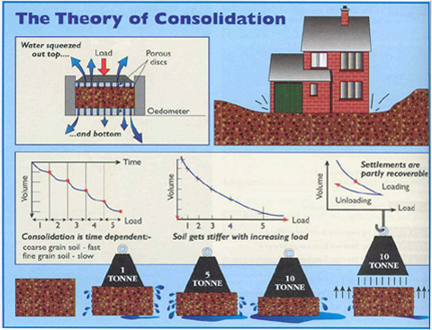
The equipment arrangement is as fallows;
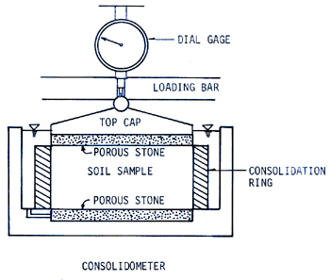

APPLICATION:
The test is conducted to determine the settlement due to primary consolidation. To determine:
- Rate of consolidation under normal load.
- Degree of consolidation at any time.
- Pressure-void ratio relationship.
- Coefficient of consolidation at various pressures.
- Compression index.
From the above information it will be possible for us to predict the time rate and extent of settlement of structures founded on fine-grained soils. It is also helpful in analyzing the stress history of soil. Since the settlement analysis of the foundation depends mainly on the values determined by the test, this test is very important for foundation design.
PROCEDURE:
- Preparation of the soil specimen:
- From undisturbed soil sample:
From the sample tube, eject the sample into the consolidation ring. The sample should project about one cm from outer ring. Trim the sample smooth and flush with top and bottom of the ring by using a knife. Clean the ring from outside and keep it ready from weighing.
- From remoulded or disturb sample :
- Choose the density and water content at which sample has to be compacted from the moisture density relationship.
- Calculate the quantity of soil and water required to mix and compact.
- Compact the specimen in compaction mould in three layers using the standard rammers.
- Eject the specimen from the mould using the sample extractor.

- Saturate two porous stones either by boiling in distilled water about 15 minute or by keeping them submerged in the distilled water for 4 to 8 hrs. Wipe away excess water. Fittings of the consolidometer which is to be enclosed shall be moistened.
- Assemble the consolidometer, with the soil specimen and porous stones at top and bottom of specimen, providing a filter paper between the soil specimen and porous stone. Position the pressure pad centrally on the top porous stone.
- Mount the mould assembly on the loading frame, and center it such that the load applied is axial.
- Position the dial gauge to measure the vertical compression of the specimen. The dial gauge holder should be set so that the dial gauge is in the begging of its releases run, allowing sufficient margin for the swelling of the soil, if any.
- Connect the mould assembly to the water reservoir and the sample is allowed to saturate. The level of the water in the reservoir should be at about the same level as the soil specimen.
- Apply an initial load to the assembly. The magnitude of this load should be chosen by trial, such that there is no swelling. It should be not less than 50 g/cm² (5 kN/m²⁾ for ordinary soils & 25 g/cm² (2.5 kN/m²) for very soft soils. The load should be allowed to stand until there is no change in dial gauge readings for two consecutive hours or for a maximum of 24 hours.
- Note the final dial reading under the initial load. Apply first load of intensity 0.1 kg/cm² (10 kN/m²) start the stop watch simultaneously. Record the dial gauge readings at various time intervals (and fill in the table). The dial gauge readings are taken until 90% consolidation is reached. Primary consolidation is gradually reached within 24 hrs.
- At the end of the period, specified above take the dial reading and time reading. Double the load intensity and take the dial readings at various time intervals. Repeat this procedure fir successive load increments.
- The usual loading intensity are as follows: 0.1, 0.2, 0.5, 1, 2, 4 and 8 kg/cm²
- After the last loading is completed, reduce the load to half (1/2) of the value of the last load and allow it to stand for 24 hrs. Reduce the load further in steps of 1/4th the previous intensity till an intensity of 0.1 kg/cm² is reached. Take the final reading of the dial gauge.
- Reduce the load to the initial load, keep it for 24 hrs and note the final readings of the dial gauge.
- Quickly dismantle the specimen assembly and remove the excess water on the soil specimen in oven, note the dry weight of it.

PRECAUTIONS:
- While preparing the specimen, attempts has to be made to have the soil strata orientated in the same direction in the consolidation apparatus.
- During trimming care should be taken in handling the soil specimen with least pressure.
- Smaller increments of sequential loading have to be adopted for soft soils.

OBSERVATION AND CALCULATION TABLE:
Pressure Intensity (Kg/cm²) | 0.1 | 0.2 |  | 0.5 |  | 1 |  | 2 |  | 4 |  | 8
Elapsed Time | Dial gauge reading
0.25 min
1 min
2.5 min
4 min
6.25 min
9 min
16 min
25 min
30 min
1 hr
2 hrs
4 hrs
8 hrs
24 hrs

Observation Sheet for Pressure Voids Ratio:
Applied pressure  σ’  (kg/cm²) | Final dial reading | Dial change  ∆H | Specimen height  H = H₁ + ∆H | Height solids  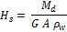 | Height of voids  H – H_{s} | Void ration  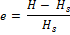
0.1
0.2
0.5
1
2
4
8
0.0

CALCULATION:
- Height of solids (H_{S}) is calculated from the equation,
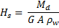
- Void ratio. Voids ratio at the end of various pressures are calculated from equation
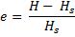
- Coefficient of consolidation:
The Coefficient of consolidation at each pressures increment is calculated by using the following equations:
- C_{v} = 0.197 d²/t₅₀ (Log fitting method)
In the log fitting method, a plot is made between dial readings and logarithmic of time, the time corresponding to 50% consolidation is determined
- C_{v} = 0.848 d²/t₉₀ (Square fitting method)
In the square root fitting method, a plot is made between dial readings and square root of time and the time corresponding to 90% consolidation is determined.
The values of C_{v} are recorded in table II.

- Compression Index:
To determine the compression index, a plot of voids ratio (e) V_{s} log t is made. The initial compression curve would be a straight line and the slope of this line would give the compression index C_{c}.

- Coefficient of compressibility: It is calculated as follows
a_{v} = 0.435 C_{c}/Avg. pressure for the increment
Where C_{c} = Coefficient of compressibility

- Coefficient of permeability. It is calculated as follows
K = C_{v}.a_{v} *(unit weight of water)/(1+e).

QUIZ:

- Consolidation of soil is due to a load which is
- Static and short term
- Dynamic and short term
- Dynamic and log term
- Static and log term
- Primary compression is mainly due to expulsion of
- Air
- Water
- Both a&b
- None
- Coefficient of consolidation depends upon
- Permeability
- Coefficient of volume change
- Unit weight of water
- All the above
- The units of coefficient of consolidation is
- cm/sec
- cm^2/sec
- cm/sec^2
- no units
- in consolidation curve fitting method is used to determine
- compression index
- swelling index
- coefficient of consolidation
- time factor
- Time factor is
- A non dimensional parameter
- A function of degree of consolidation
- Directly proportional to permeability
- All the above
- If the coefficient of permeability is doubled and coefficient of volume compressibility is halved the coefficient of consolidation
- Increased by 2 times
- Decreased by 2 times
- Decreased by 4 times
- Increased by 4 times
- The ratio of settlement at any time t to the final settlement is known as
- Coefficient of consolidation
- Degree of consolidation
- Time factor
- Consolidation of undisturbed soil

PART – 2
ANIMATION STEPS
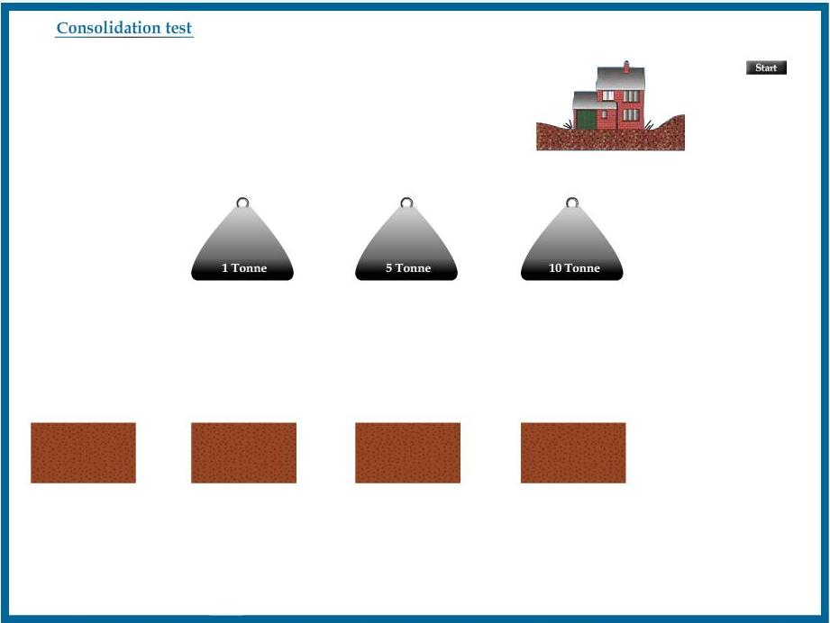

PART – 3
VIRTUAL LAB FRAME

